Mango23

Vamsi@123

#R3dSun$et

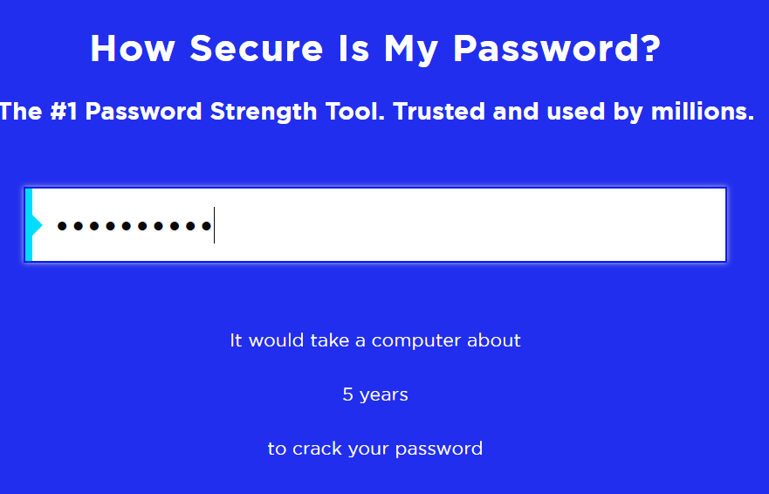

Gl@ssW@ter2024

Simple: Mango23

Medium: Vamsi@123

High: #R3dSun$et

Very Strong: Gl@ssW@ter2024